ACTIVITIES CONDUCTED BY NSS and RED CROSS to make students to understand their responsibilities as a good citizen.

On 10TH February 2023, pt. JLN govt. college, NSS cell organise two days cleanliness camp to make students to understand importance of cleanliness and environment.

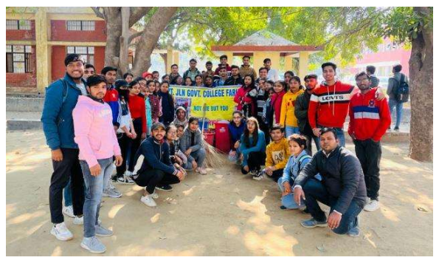 On 8TH February 2022, pt. JLN govt. college, NSS cell organise rally for awareness about importance of voting to make them a responsible citizen.

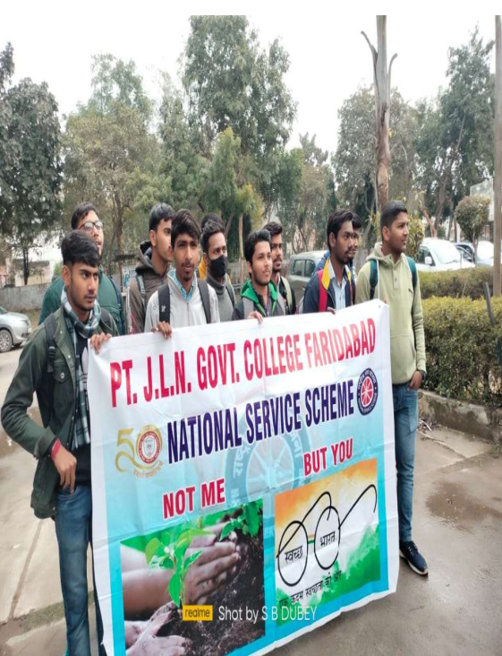

On 17th December 2022, pt. JLN govt. college, NSS cell organise a blood Donation camp .

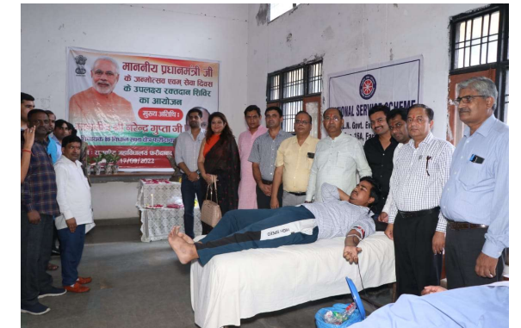

On 22 July 2022 NSS cell organized a rally on importance of De-addiction to make students to understand the importance of de-addiction and how it is important to our society.

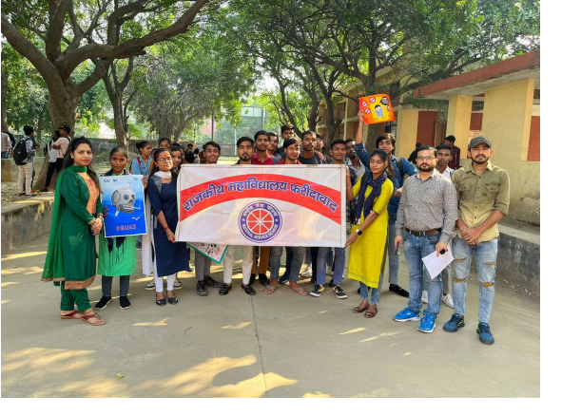

**ACTIVITIES CON DUCTED BY LEGAL LITERACY CELL**

Different t activities like poetic recitation, debate competition, skit competition, Essay writing competition etc. organised by **Legal Literacy Cell** to create awareness among students about constitutional rights and duties. Also make them to understand responsibilities as a citizen

