**Report of Legal Literacy Cell- Session 2022-23**

Legal literacy cell organized **college level competitions**- Essay Writing, Debate, Declamation, Poetic Recitation, Quiz, Slogan, On the Spot Painting, PPT, Documentary on **17.06.22**. More than 50 students participated in these competitions. Refreshment was given to participants and staff members who were on duty.

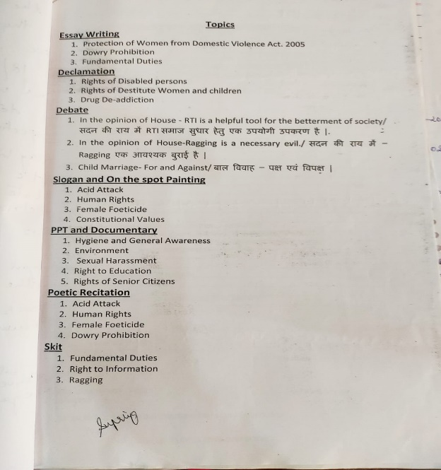

Legal Literacy Cell of the college under the aegis of IQAC organized **District Level Competitions** like Essay Writing, Poetic Recitation, Debate, Declamation, Skit, On the Spot Painting, Slogan, PPT, Documentary and quiz **on 30.11.2022** in which approximately 90 students from various colleges participated. Under the guidance of Principal, Dr. M.K.Gupta, Dr. Ruchira Khullar, Officiating Principal and the Chief Guest of the occasion, addressed the participants and elucidated on the need and importance of legal literacy awareness programs and competitions among college students. Certificates and Cash prize of Rs.500, Rs.300 and Rs.200 were presented to the First, Second and Third position holders respectively. Certificates were also given to all the participants. Refreshment was given to all the participants and team in charges. The students of the college bagged First prize in Quiz, Debate, Documentary and Declamation, Second prize in PPT, On the Spot Painting, Poetic Recitation, Third prize in Declamation and PPT. The best speaker in Debate was bagged by our student.

<https://hindustanabtak.com/judicial-literacy-cell-of-nehru-college-organized-district-level-competition/>

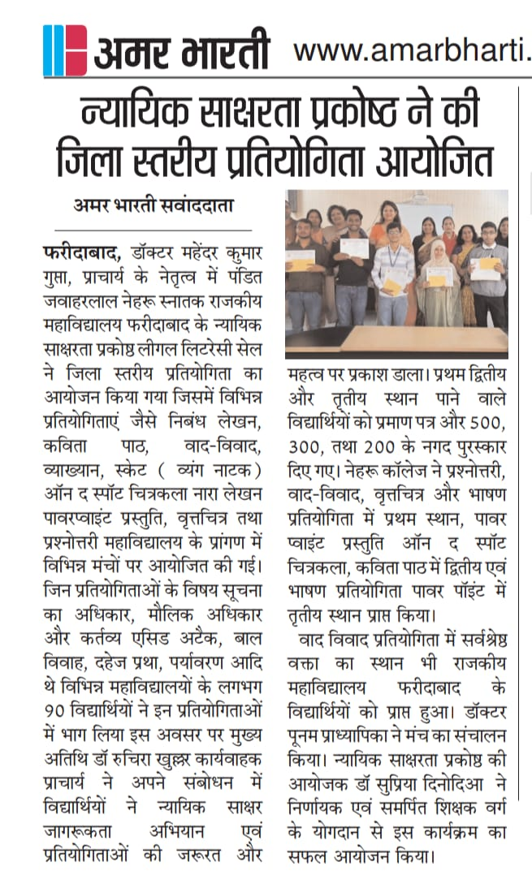

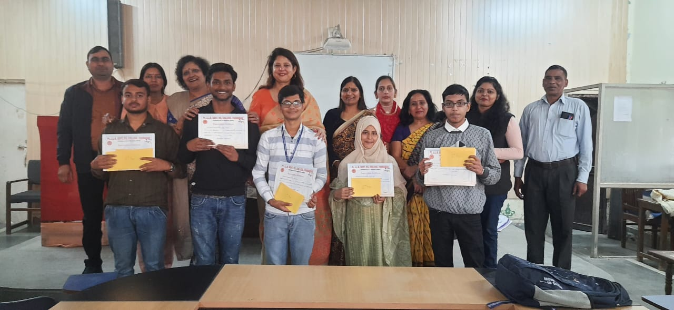

Under the guidance of Principal, Dr. M.K. Gupta, Legal Literacy Cell of the college organized **Divisional Level Competitions** like Essay Writing, Poetic Recitation, Debate, Declamation, Skit, On the Spot Painting, Slogan, PPT, Documentary and quiz on **18.04.2023** in which approximately 45 students who were winners of district level competitions of Faridabad and Palwal district participated. Dr. M.K.Gupta, addressed the participants and elucidated on the need and importance of legal literacy awareness programs and competitions among college students. Certificates and Cash prize of Rs.500, Rs.300 and Rs.200 were presented to the First, Second and Third position holders respectively. Certificates were also given to all the participants. Refreshment was given to all the participants and team in charges. The panel of judges included Retired Principals - Dr. D.K.Sharma, Dr. R.C. Vashishth, Dr. Rohtash Kumar; Retired Associate Professors- Dr. Mukesh Bansal, Dr. Taramani Jindal and Officiating Principal Dr. Babulal Sharma. Senior faculty members Dr. Ruchira Khullar and Dr. Rajesh Kumar also graced the occasion. Our college bagged first position in four events and second position in one event. Dr. Jorawar Singh and Dr. Poonam conducted the main stage. Dr.Nisha Tewatia was the Quiz master. Dr Anshu Nayyar presented vote of thanks to the chief guest, judges, team incharges and participants. Ms. Supriya Dinodia, Convener Legal Literacy Cell organized the event with the support of dedicated faculty members Dr. Neetu Sorout, Dr. Pooja Singh, Dr. Devender, Dr. Sita Dagar, Dr. Richa Bansal, Dr. Sanjeev Kumar and Dr. Anita Yadav.

<https://hindustanabtak.com/divisional-level-competitions-organized-by-legal-literacy-cell/>

<https://m.facebook.com/story.php?story_fbid=pfbid02Fea7uRiQcvsfWjPzmkw3L7v4afYwq1aXzDjiATvpjApjz1Q8YvvBcVsMqU6Hx6TJl&id=100068193191771&mibextid=Nif5oz>

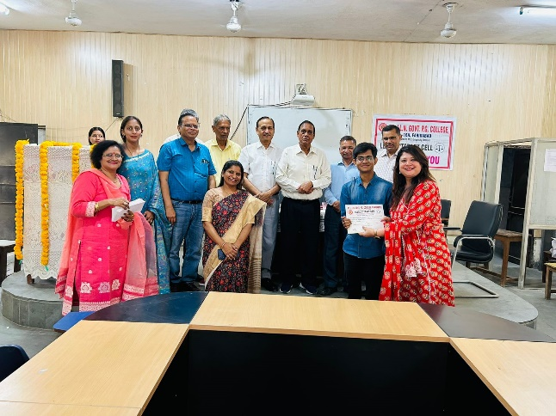 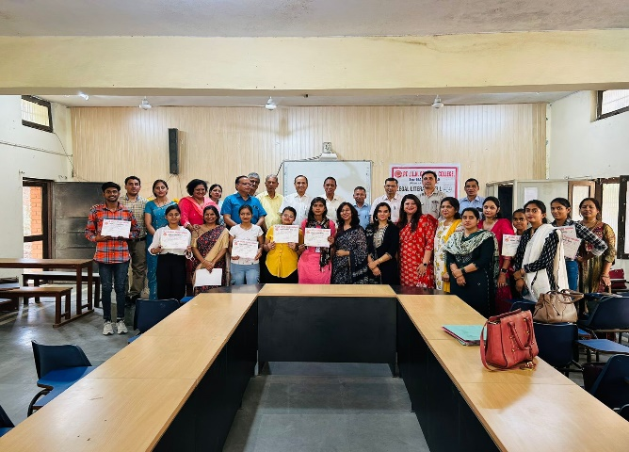

It is a matter of immense pride that our students bagged following positions in **State level Competitions under Legal Literacy Cell held at Govt. PG College, Sector 1, Panchkula on 25.04.23.**

1st Position in Debate- Yash Kalra (BSc Pass 1st Year)

2nd Position in PPT- Babloo (English H 1st Year)

3rd Position in Quiz-Bobby Bhati (BSc Pass 3rd Year) and Suraj (MA Eco 1st Year)

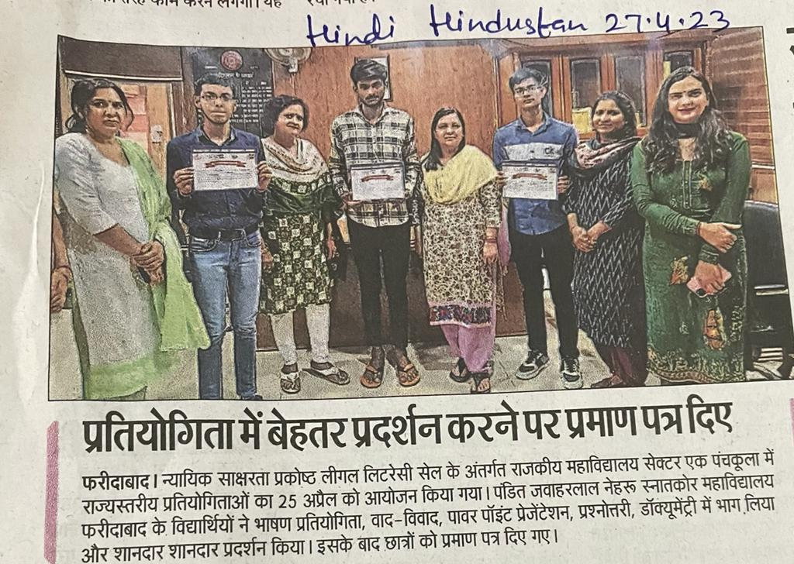 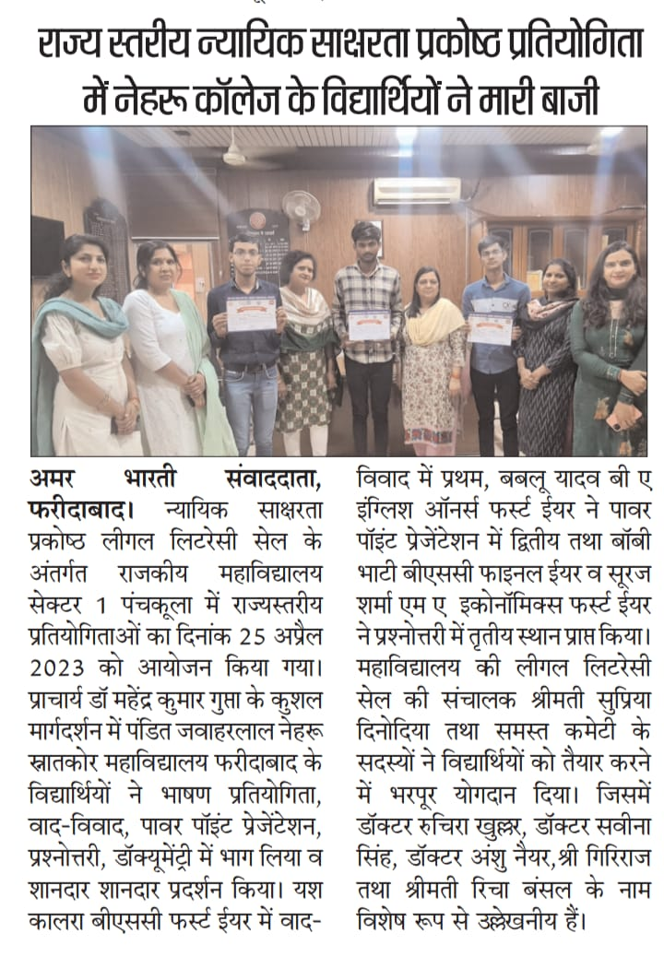

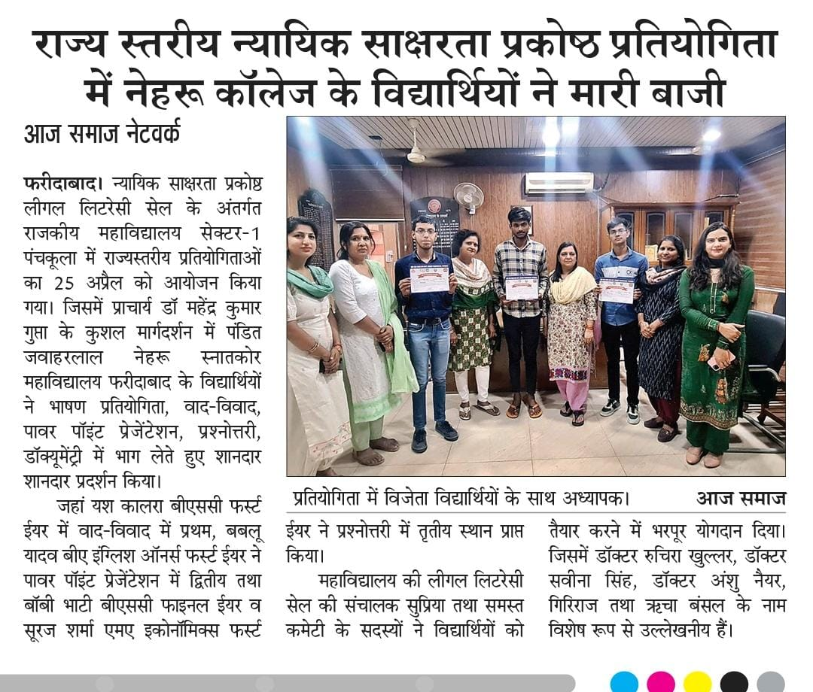

Convener- Legal Literacy Cell

Ms. Supriya Dinodia