**Report of Legal Literacy Cell – Session 2023-24**

Under the able guidance of Dr. Ruchira Khullar, Principal Pt. J.L.N. Govt. College, Faridabad, **college level** **competitions under Legal Literacy Cell** - **Essay Writing, Poetic Recitation, Debate, Declamation, Skit,** **Quiz, On the Spot Painting, Slogan** were conducted on **04.03.24**. **PPT and Documentary** competitions were organized on **06.04.24**. The event was organized by the convener of Legal Literacy Cell, Ms. Supriya Dinodia along with the team members Dr. Anshu Nayyar, Dr. Renu Yadav, Dr. Anita Yadav and Dr. Devender Singh. The **prize distribution ceremony** was conducted on **11.04.24** in which Principal Dr. Ruchira Khullar presented certificates and cash prizes of Rs 500, Rs.300 and Rs. 200 to the first, second and third position holders respectively. The Principal Dr. Ruchira Khullar congratulated and gave the best wishes to the winners. Approximately 70 students participated in these competitions. <https://m.facebook.com/story.php?story_fbid=pfbid0tyjn4Fg2wjvtgskDLFdhPqqRF8G7D7DPMkDTEiRRA2pnFTZhFAah4uvETqRUGdCxl&id=100068193191771&sfnsn=wiwspwa&mibextid=RUbZ1f>

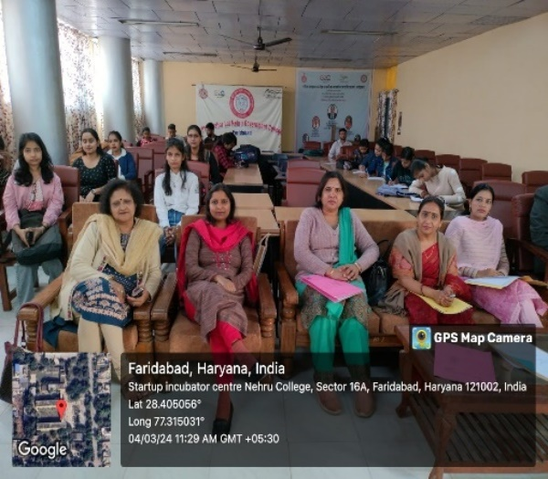 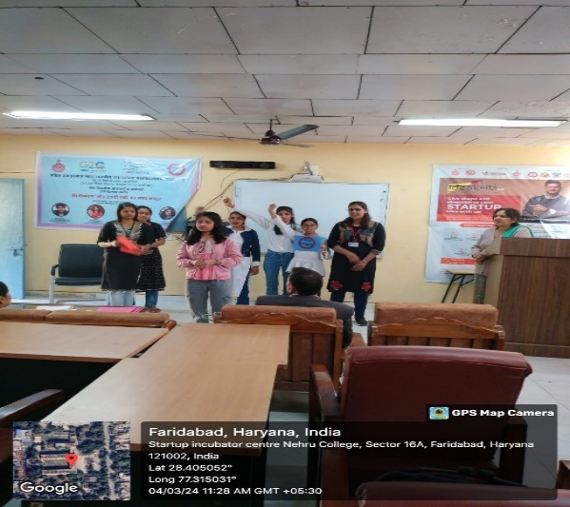

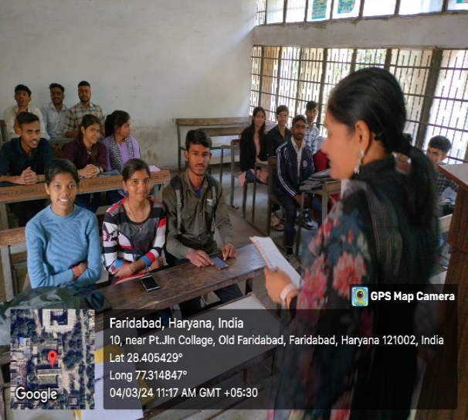 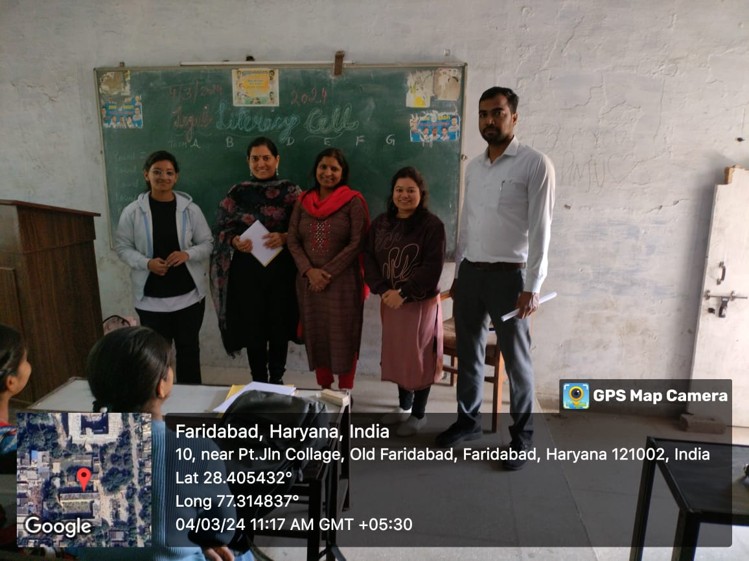

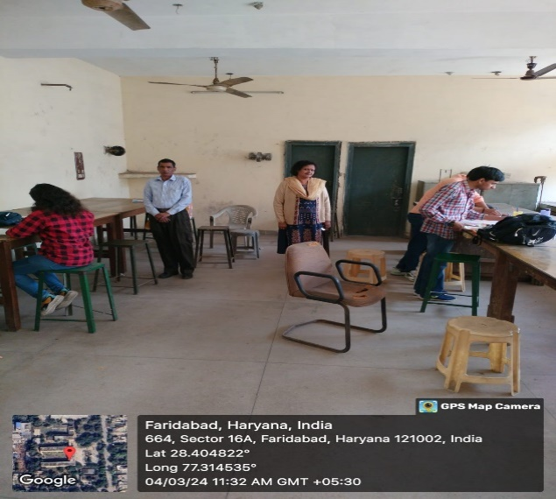 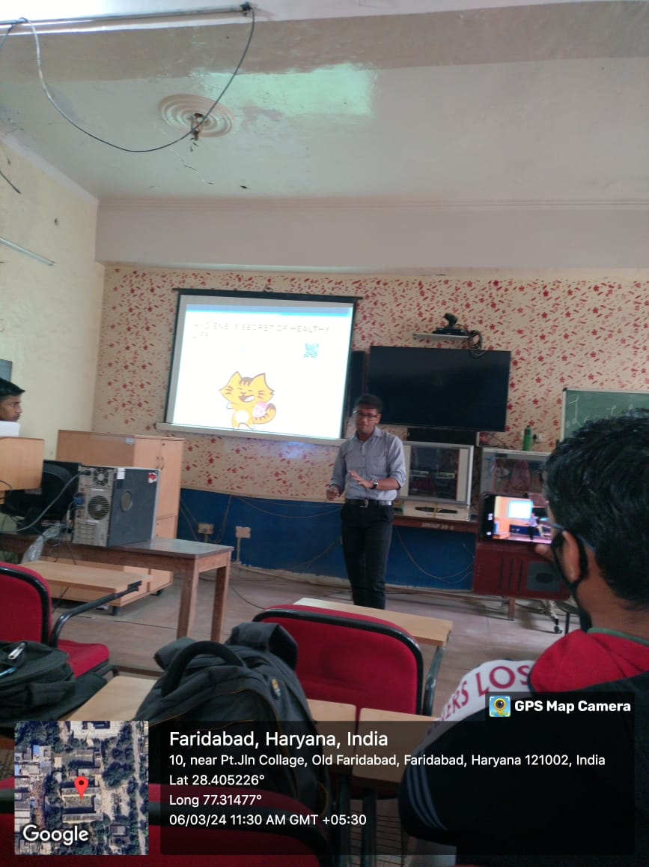 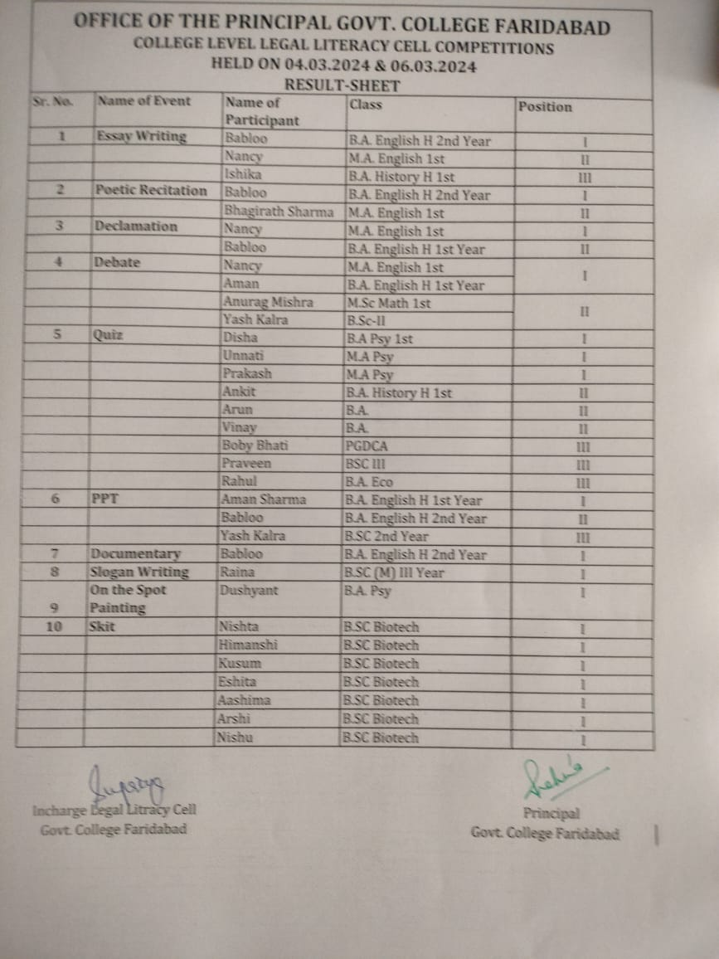 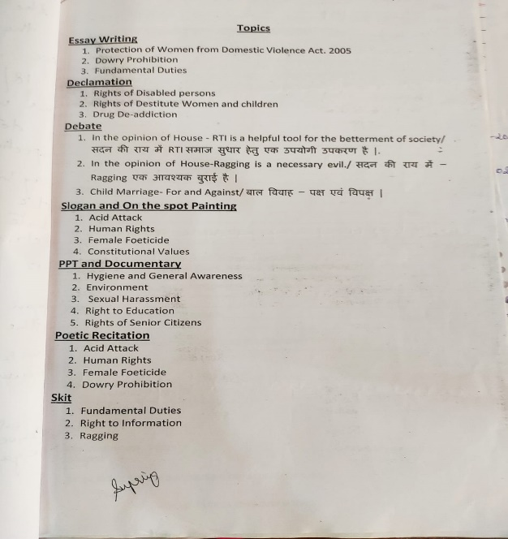 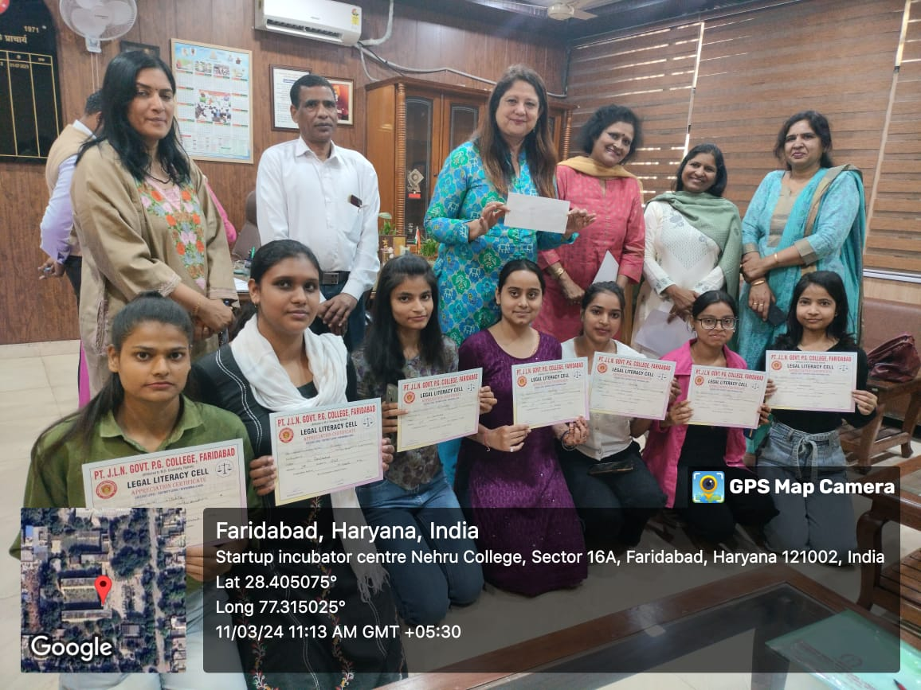 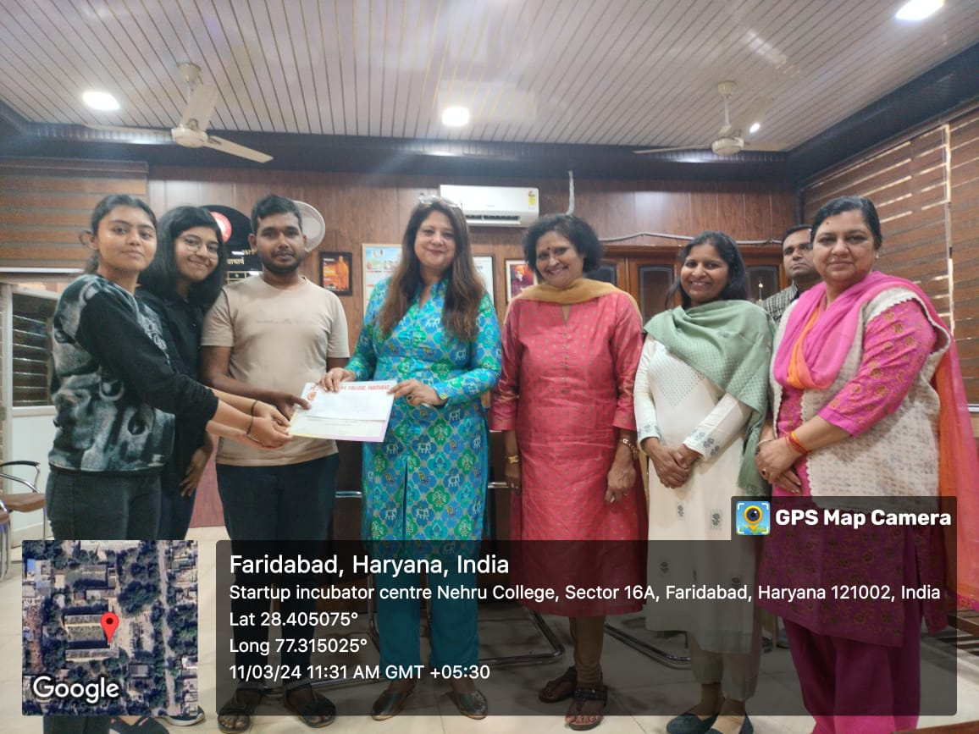 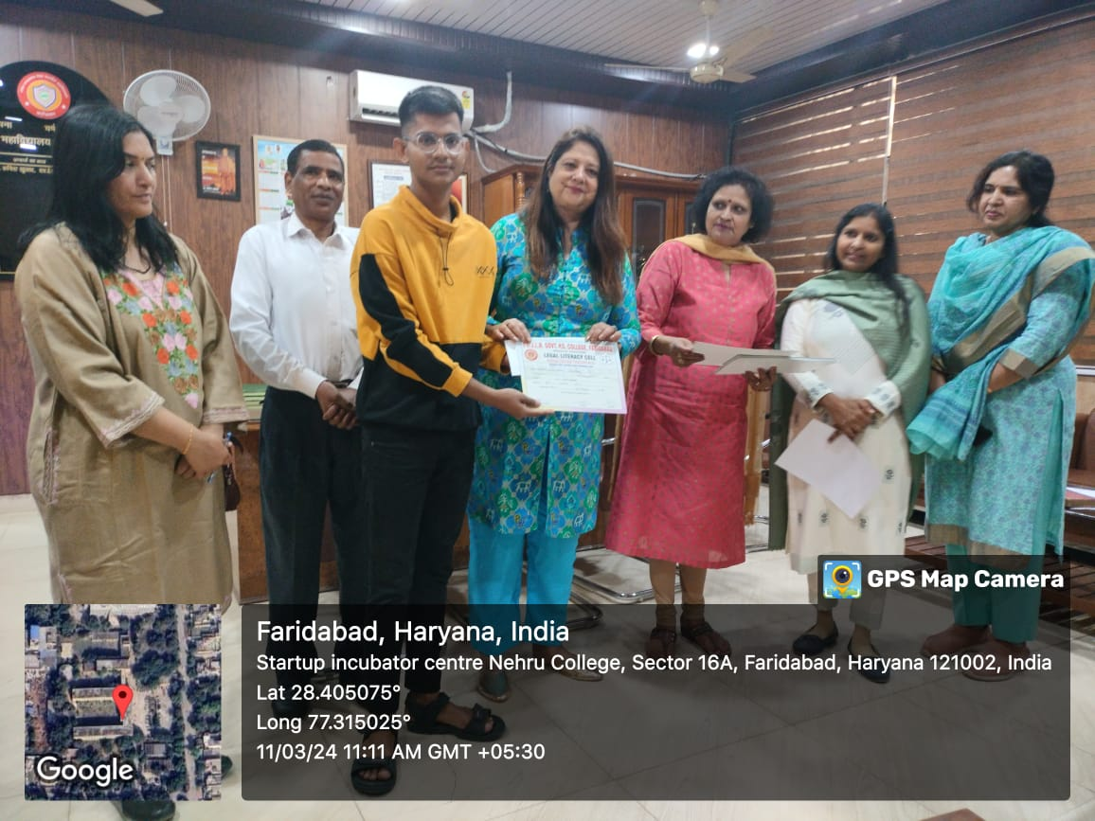 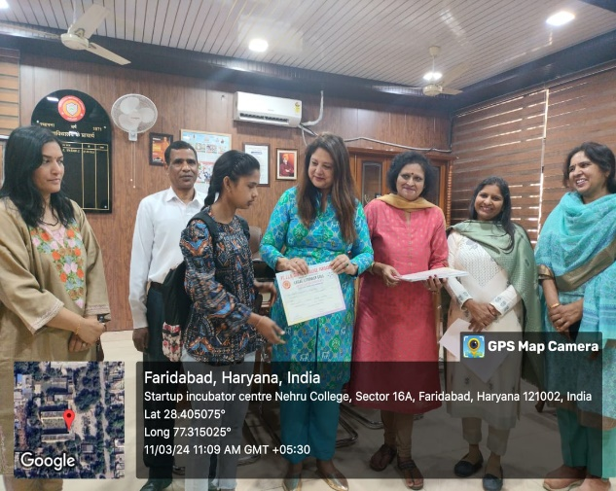

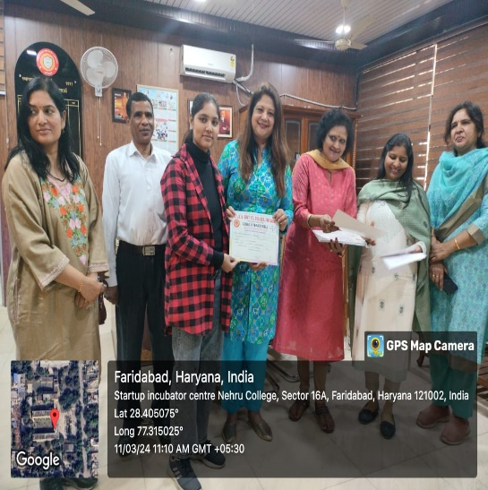 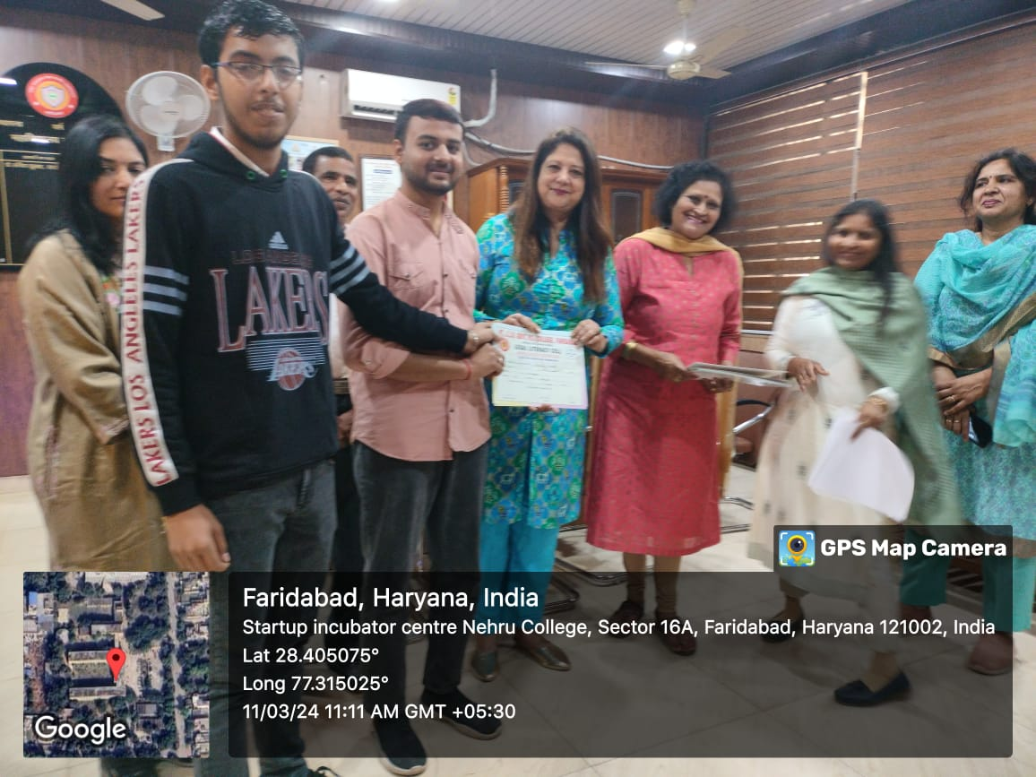

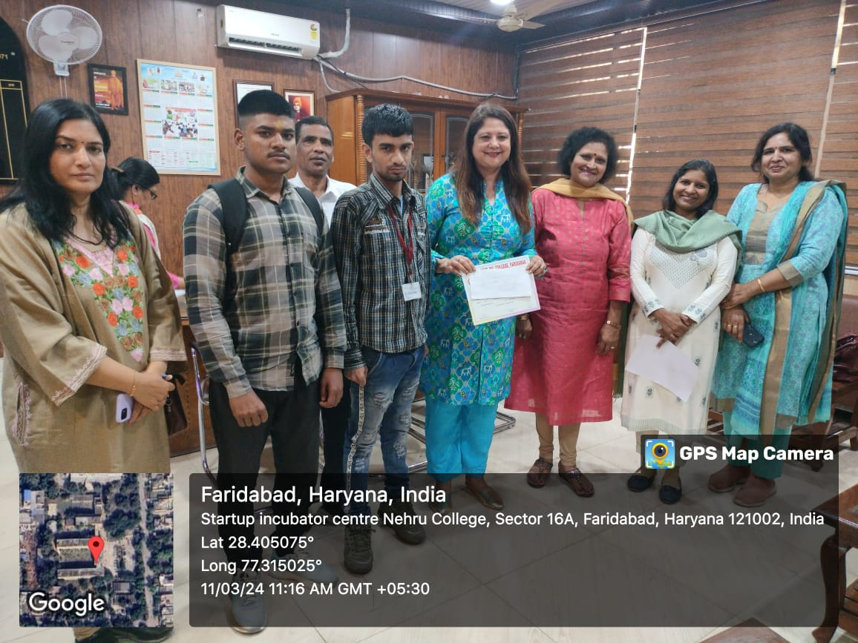 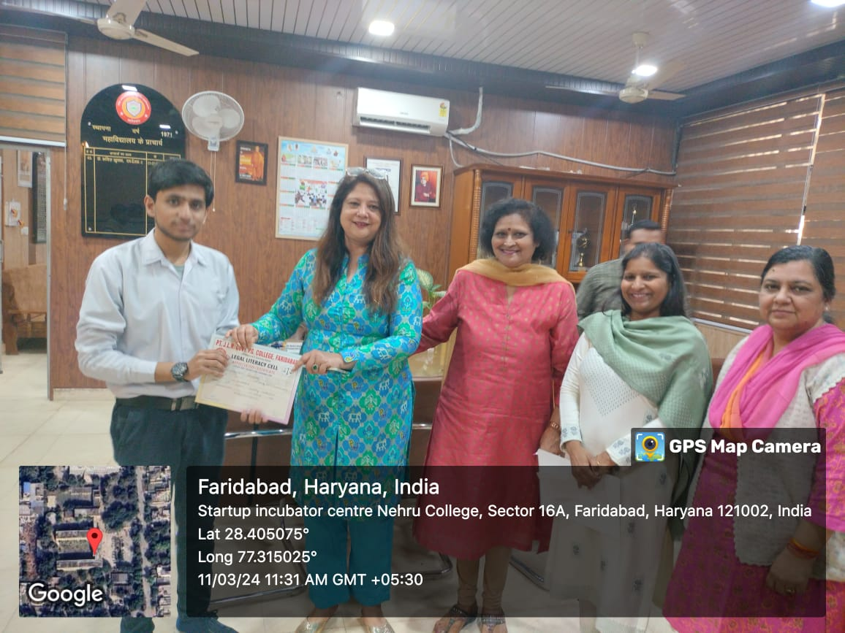

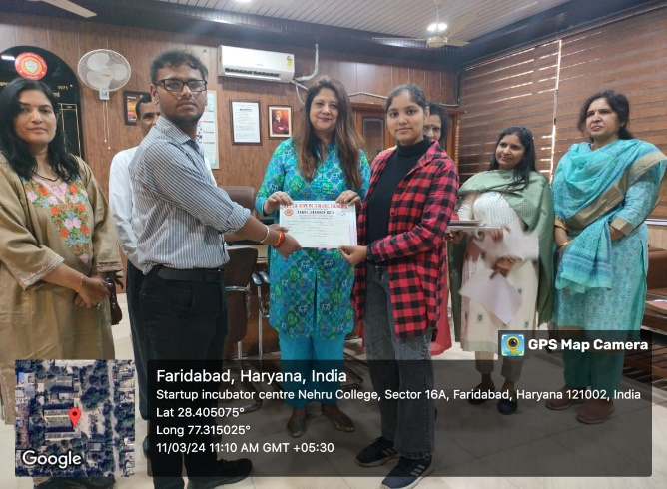

**Ten students** of the college participated in **District level competitions** organized under Legal Literacy Cell by **Govt. College for Women** on **26.04.2024**. It is a matter of immense pride that our students won the following positions in the above-mentioned competitions-

1st Position in PPT - Yash Kalra

1st Position in Debate (For the Motion) - Nancy

1st Position in Debate (Against the Motion) - Anurag Mishra

2nd Position in PPT - Aman Sharma

2nd Position in Documentary - Babloo

2nd Position in Declamation - Babloo

2nd Position in Debate (Against the Motion) - Aman Sharma

<https://www.facebook.com/share/p/kwL12Vph4HUa1Zvx/?mibextid=xfxF2i>

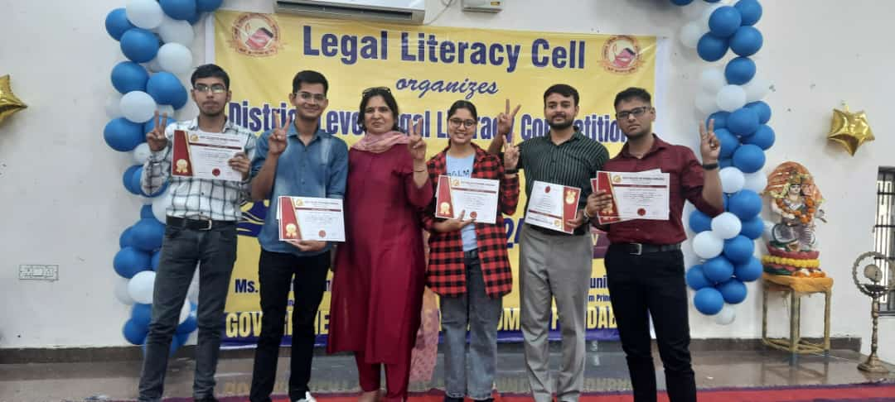 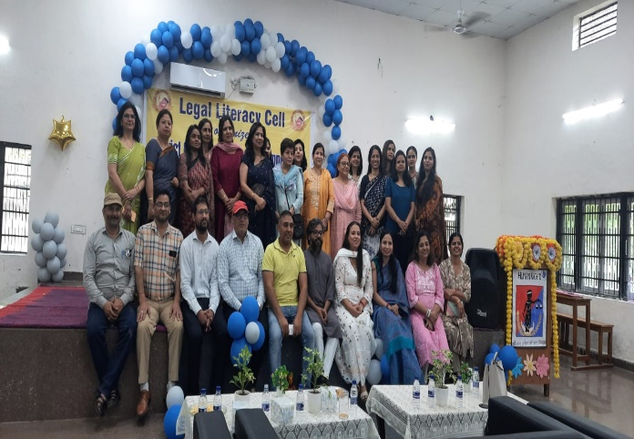

Ms. Supriya Dinodia

Convener Legal Literacy Cell