Date: 21/10/2024
Event: Seminar on Full Stack Development
A seminar was organized in the Computer Department on 21st October 2024 under the guidance of Principal Dr. Vashisht in Pandit Jawaharlal Nehru Government College, Faridabad. The seminar was organized by an organization named Unique ERP. The topic of the seminar was Full Stack Development. Full Stack Development is a very modern and popular method in the world of IT. About 100 students from various departments participated in the seminar and took advantage of the seminar. The duration of the seminar was about 1 hour. Dr. Poonam Ahlawat, HOD of Computer Department, Madam Anu Khanna, Madam Richa, Madam Radha, Madam Ritu, Dr. Ranjita, Dr. Sonika, Surendra Sir, Madam Shalu, Madam Rashmi, Madam Nidhi, Madam Rajni, Madam Ruchika, Madam Kalpana, Madam Suman, Madam Isha were present in the seminar. At the end of the seminar, Principal Dr. Vashisht met the team of Unique ERP and honoured them.
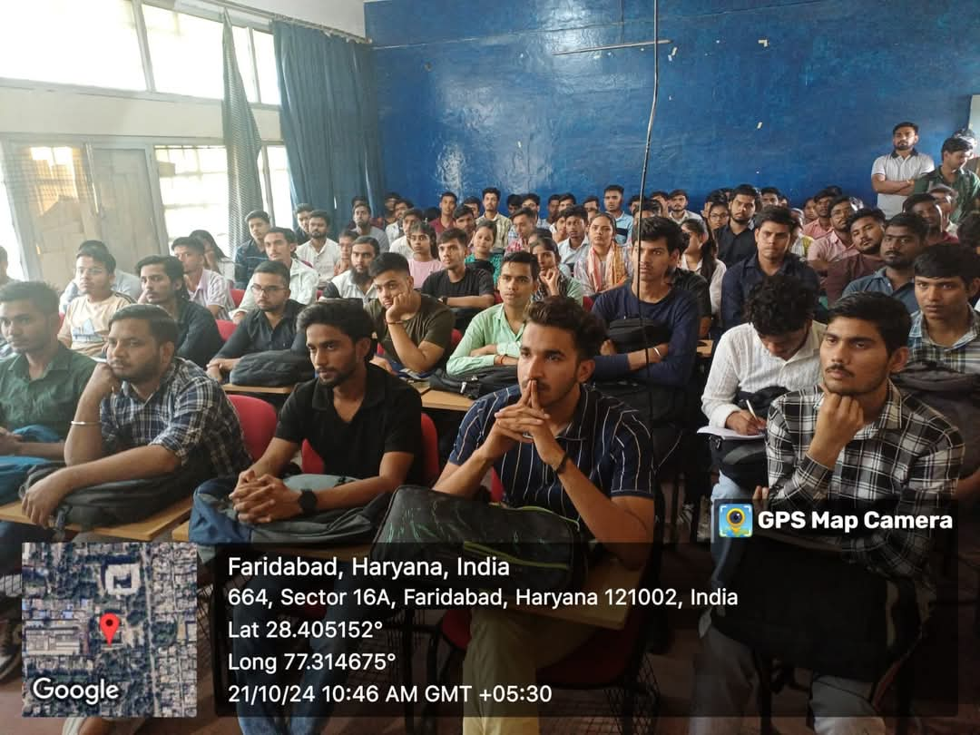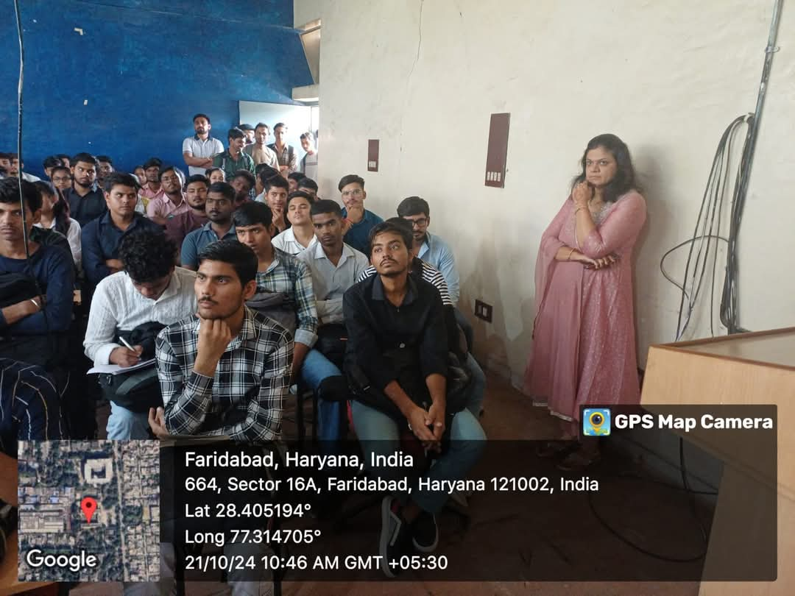

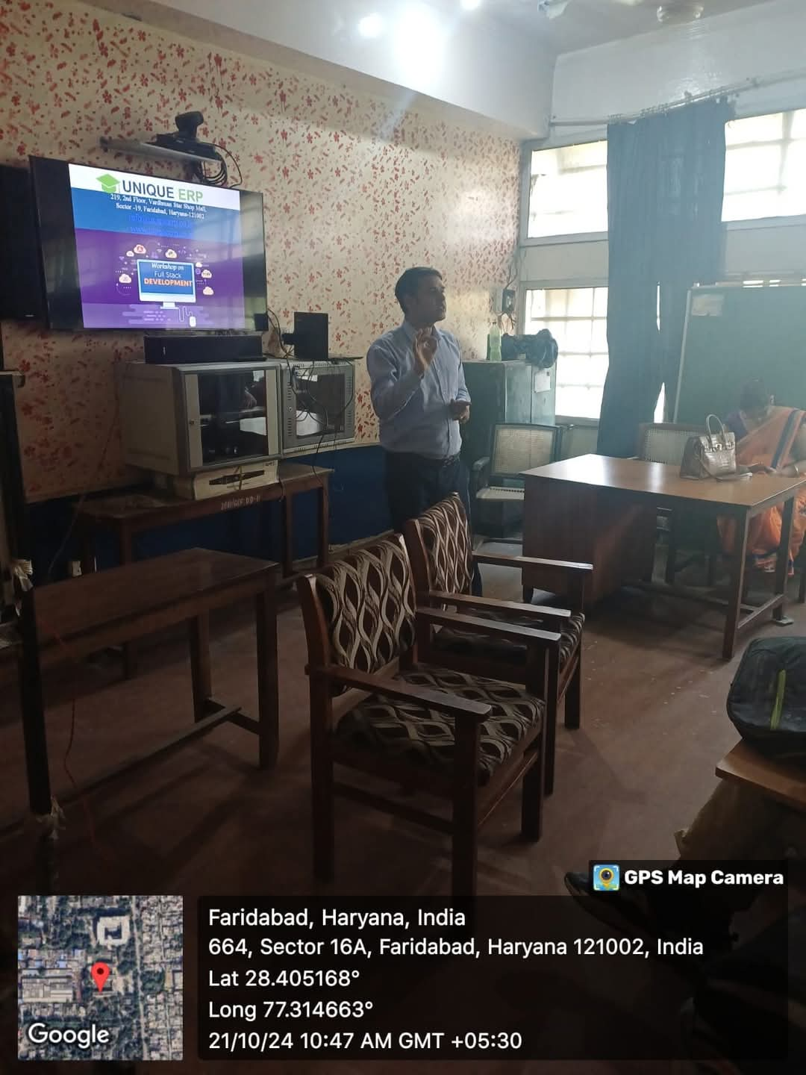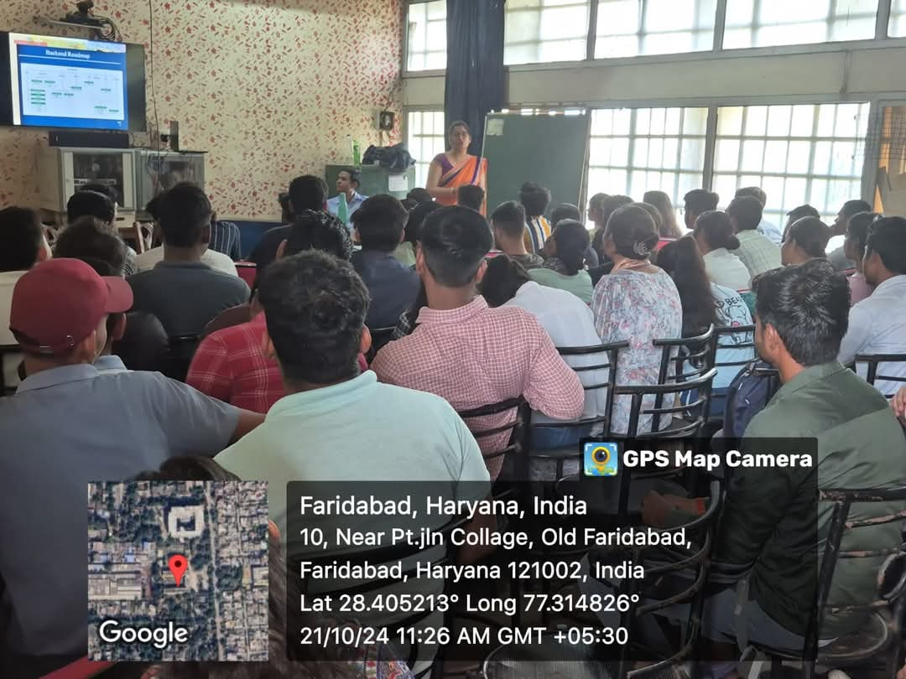

Date: 22/11/2024
Event: Expert Lecture on Quantum Computing
An online seminar on topic "Quantum Computing" was done on 22/11/2024 by Computer Deptt. HOD Dr Poonam started the session by greeting "Mr Umesh" Assistant Professor YMCA. Approximately 90 Students from BCA, BSC Computer science, MSC Computer Sc joined the Google meet. Mr Surender introduced Mr Umesh and gave an introduction on the topic too. Session was technically highly elaborative. Numerous aspects of Quantum Computing were shared in a simple language to make participants clear. Q/A session was taken by Mr Umesh. Dr Poonam concluded the session by thanking Mr Umesh for sharing the insights with all the participants.
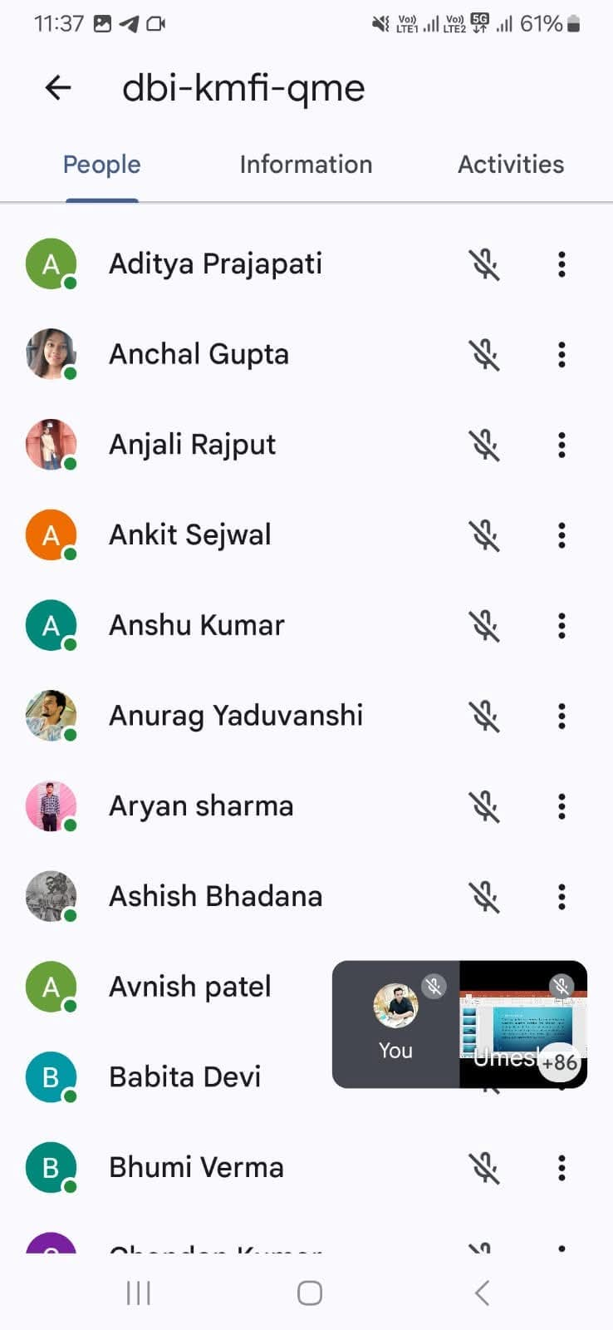
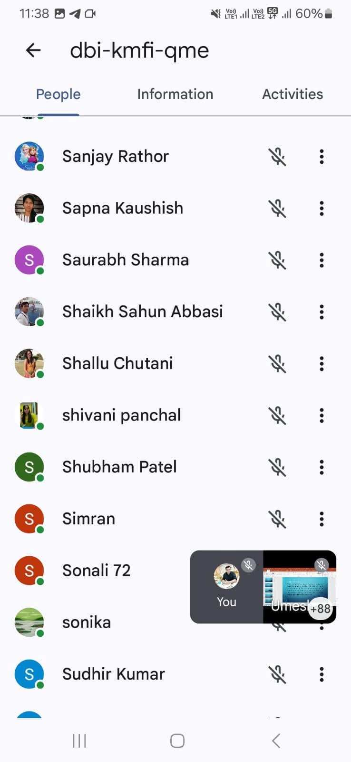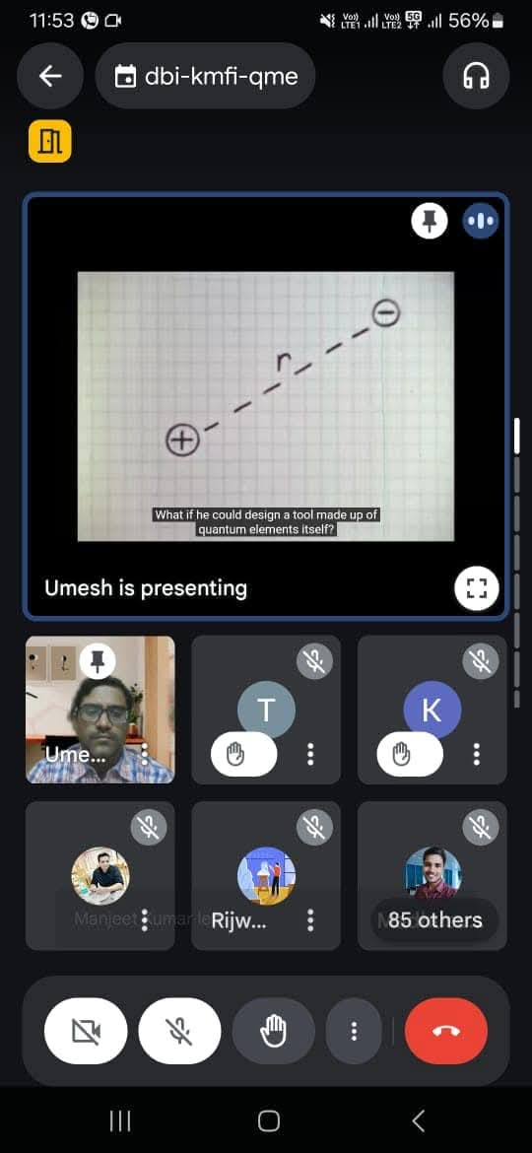

Date: 28 march 2025
Expert lecture on machine learning
Under the able guidance of respected Principal sir. , Dr. Chander Shekhar Vashisht , Computer Department of the college organised lecture on the topic machine learning by Dr. Neerja Negi, associate professor MRIIS. The lecture emphasised upon various applications of machine learning and different models that are implemented in different fields of AI. More than 50 students attended the session . Dr Ranjita Joon, Ms. Sonika, Mr. Ravinder, Dr. Ritu Sharma, Dr. Kalpana , Dr. Isha Bhatia, Dr. Rajni, Dr. Ruchika, Ms. Anu Khanna, Er. Richa Bansal encouraged the students to attend the session .
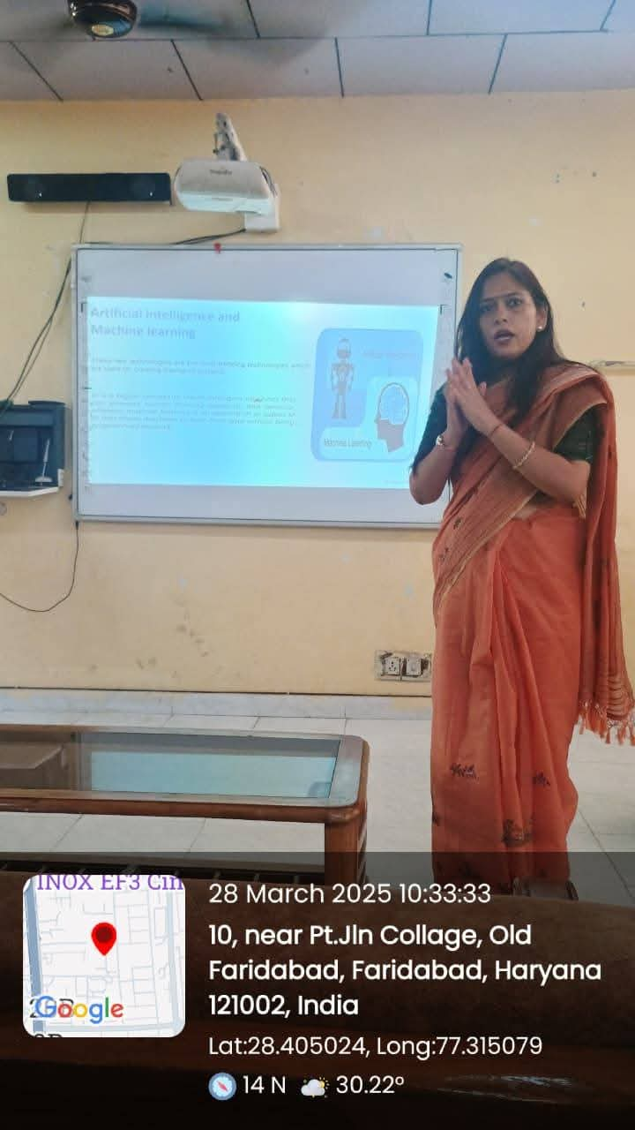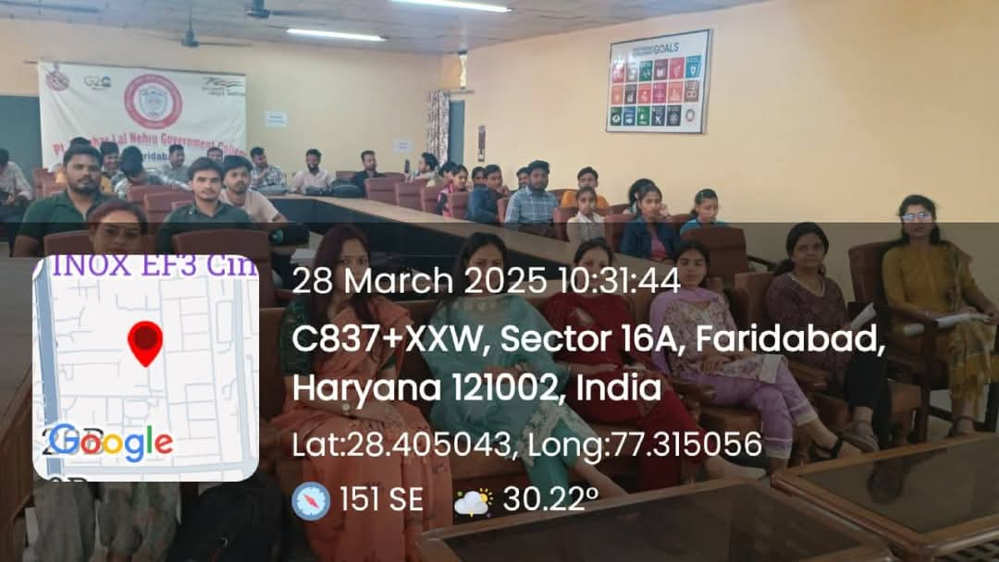

Date: 1/5/2025
Event: Expert Lecture on “Wireless Network Security Protocols”
Under the able guidance of Principal Dr. Ruchira Khullar, computer science department of college organized an expert lecture on the topic 'wireless network security protocols'. Dr. Umesh from JC Bose University enlightened the students upon various protocols of wireless network security such as WPS, WPA2, WPA3 and many more. More than 150 students attended the lecture and gained knowledge on different protocols. Dr. Ranjita Joon, Mr Ravinder, Ms. Sonika, Dr Ritu Sharma Dr. Kalpana Dr. Rajni Dr. Ruchika Arora Dr. Isha Bhatia Dr. Nidhi, Dr. Radha, Er. Richa Bansal, Ms Anu Khanna, Mr. Surender encouraged the students and made the event successful

